Class Notes: Supervised Learning

1. Definition
Supervised Learning is a type of machine learning where the model is trained on a labeled dataset.
This means that each training example is paired with an output label.
The goal is to learn a mapping from inputs to outputs, which can then be used to predict outcomes for new, unseen data.

2. Types of Supervised Learning

2.1 Classification
Classification is used when the output variable is a category, such as 'spam' or 'not spam'.
The model learns to assign input data to one of several predefined categories.

2.2 Regression
Regression is used when the output variable is a real value, such as 'house price'.
The model learns to predict continuous values based on input features.

3. Workflow of Supervised Learning
- Data Collection
- Data Preprocessing
- Splitting Data into Training and Testing Sets
- Model Selection
- Training the Model
- Model Evaluation
- Prediction on New Data

4. Common Algorithms
- Linear Regression
- Logistic Regression
- Decision Trees
- Random Forest
- Support Vector Machines (SVM)
- k-Nearest Neighbors (k-NN)
- Neural Networks

5. Advantages
- Easy to understand and implement
- High accuracy with sufficient labeled data
- Applicable to a wide range of problems

6. Limitations
- Requires a large amount of labeled data
- Performance depends heavily on the quality of data
- Can be computationally expensive

7. Real-Time Numerical Examples

7.1 House Price Prediction (Regression)

Suppose we have a dataset of houses with features like size (in sq ft), number of bedrooms, and location. We want to predict the price of a house.
Example:
Input: Size = 2000 sq ft, Bedrooms = 3, Location = Suburban
Output: Price = ₹50,00,000
Model: Linear Regression

Here’s a detailed breakdown of the House Price Prediction example, along with a graphical visualization of the dataset and regression model.

House Price Prediction (Regression)
1. Problem Setup
We want to predict the price of a house using features:
- Size (sq ft)
- Number of bedrooms
- Location (Urban, Suburban, Rural)
This is a Regression Problem because the output (price) is a continuous numerical value.

2. Dataset Structure
House ID | Size (sq ft) | Bedrooms | Location | Price (₹)
H1 | 1200 | 2 | Urban | 35,00,000
H2 | 2000 | 3 | Suburban | 50,00,000
H3 | 1500 | 2 | Rural | 25,00,000
H4 | 2500 | 4 | Urban | 70,00,000
H5 | 1800 | 3 | Suburban | 45,00,000

3. Graphical Structure of Data
The scatter plot below shows:
- X-axis: House size (sq ft)
- Y-axis: Price (₹)
- Colors/Shapes: Different locations (Urban, Suburban, Rural)
- Regression Line: Best-fit line showing the trend between size and price
- Highlighted Point: Example input (2000 sq ft, 3 bedrooms, Suburban) with predicted price ≈ ₹50,00,000
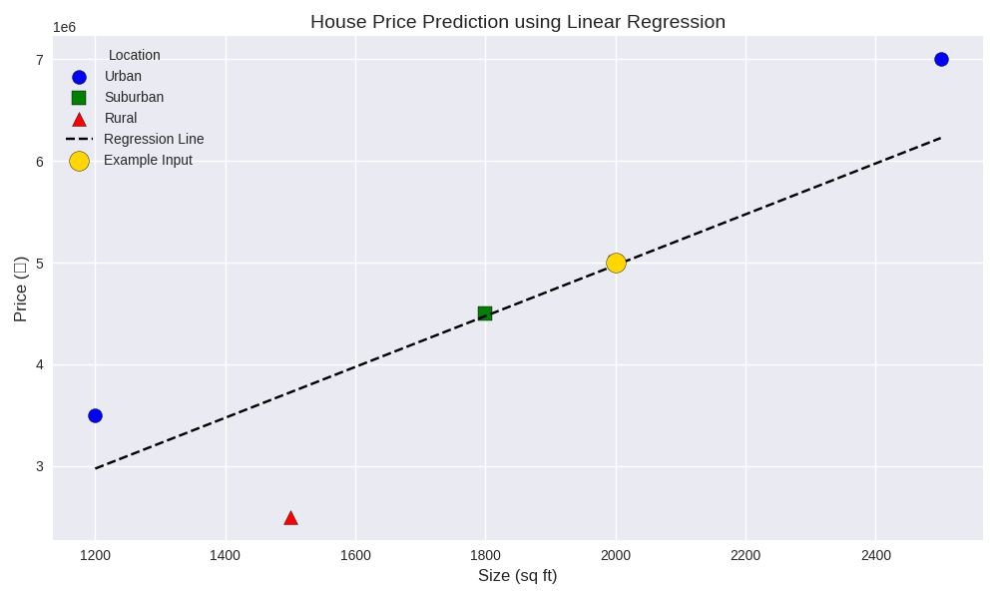

4. Model Explanation
The Linear Regression model fits a line to minimize prediction error.
Equation form:
- 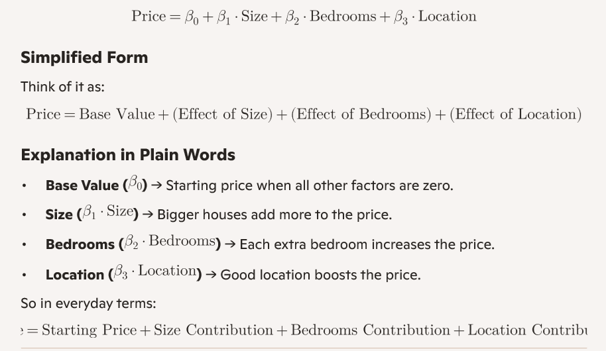Size: Larger houses → higher prices.
- Bedrooms: More bedrooms → higher prices.
- Location: Encoded numerically (Urban, Suburban, Rural) to capture regional differences.

5. Real-Time Prediction
For the example input:
- Size = 2000 sq ft
- Bedrooms = 3
- Location = Suburban
The model predicts:
{Price} IS approx ₹50,00,000

Python code:
We want to predict house prices using:
- Size (numerical)
- Bedrooms (numerical)
- Location (categorical: Urban, Suburban, Rural)

import pandas as pd
from sklearn.linear_model import LinearRegression
from sklearn.preprocessing import OneHotEncoder
from sklearn.compose import ColumnTransformer
from sklearn.pipeline import Pipeline

# Sample dataset
data = pd.DataFrame({
'Size': [1500, 1800, 2400, 3000, 2000],
'Bedrooms': [3, 4, 3, 5, 3],
'Location': ['Urban', 'Suburban', 'Rural', 'Urban', 'Suburban'],
'Price': [4000000, 4800000, 5200000, 6500000, 5000000] # in ₹
})

# Features and target
X = data[['Size', 'Bedrooms', 'Location']]
y = data['Price']

# Preprocessing: One-hot encode 'Location'
preprocessor = ColumnTransformer(
transformers=[
('loc', OneHotEncoder(), ['Location'])
],
remainder='passthrough' # keep other columns
)

# Pipeline: preprocessing + regression
model = Pipeline(steps=[
('preprocessor', preprocessor),
('regressor', LinearRegression())
])

# Train the model
model.fit(X, y)

# Predict for new input
new_data = pd.DataFrame({
'Size': [2000],
'Bedrooms': [3],
'Location': ['Suburban']
})

predicted_price = model.predict(new_data)
print(f"Predicted Price: ₹{int(predicted_price[0]):,}")

7.2 Email Spam Detection (Classification)

We have a dataset of emails labeled as 'spam' or 'not spam'. Features include frequency of certain keywords, sender address, and email length.
Example:
Input: Contains 'win', 'free', 'click', Sender = unknown
Output: Spam
Model: Naive Bayes or Logistic Regression

Let’s turn your Email Spam Detection example into a clear graphical-style structure so it’s easy to visualize how the classification works.

Graphical Structure of Spam Detection
1. Input Layer (Features)
- Keywords Frequency → e.g., "win", "free", "click”
- Sender Address → e.g., "unknown"
- Email Length → number of words/characters
2. Feature Vector Representation
X = [{Keyword Frequency}, {Sender}, {Length}] ]
For your example: X = [{win, free, click}, {unknown}, {short}] ]

3. Model (Classifier)
- Naive Bayes → calculates probability of spam vs. not spam using Bayes’ theorem.
- Logistic Regression → computes weighted sum of features and applies sigmoid to predict spam probability.
Graphically:
- Features → Model (Naive Bayes / Logistic Regression) → Prediction

4. Output Layer (Decision)
- Spam (label = 1)
- Not Spam (label = 0)

Visual Flow Diagram (Textual Representation):
- This structure shows the pipeline:
Email → Extract Features → Apply Model → Predict Spam/Not Spam.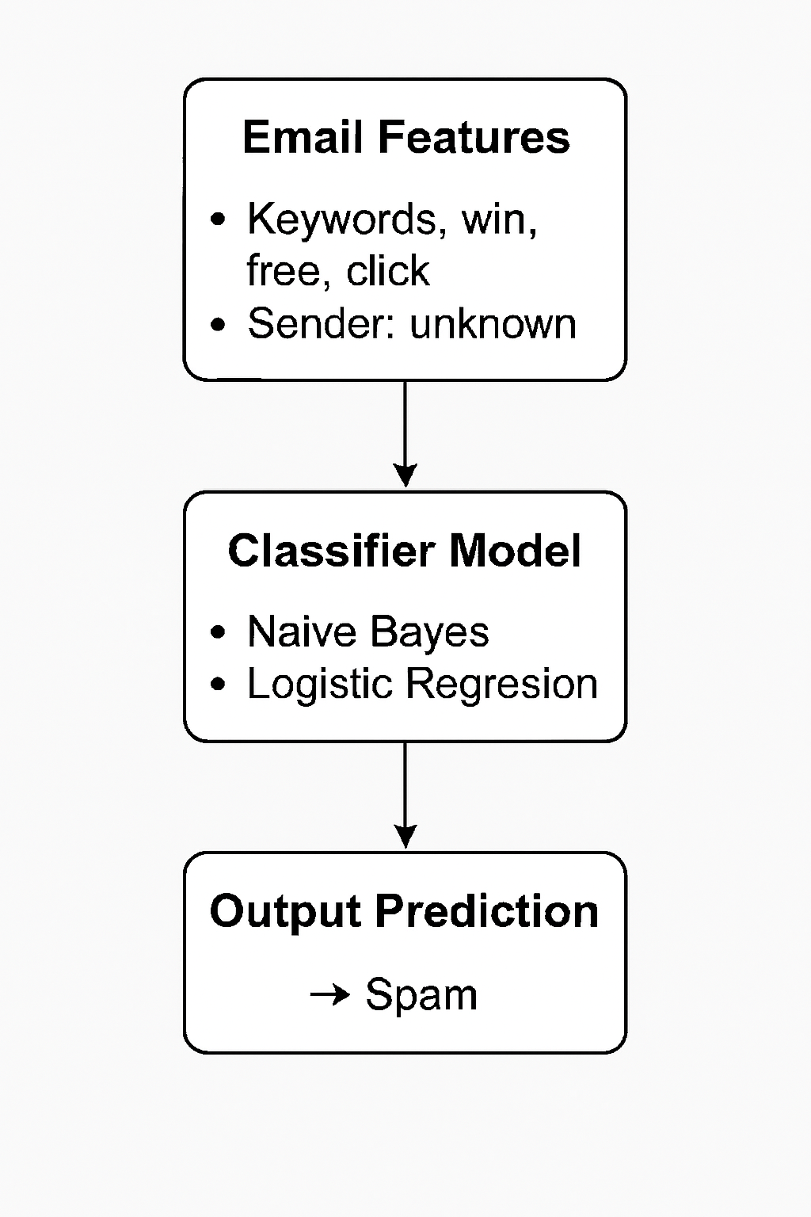

Here’s your side-by-side comparison diagram showing how Naive Bayes and Logistic Regression handle the same email input for spam detection
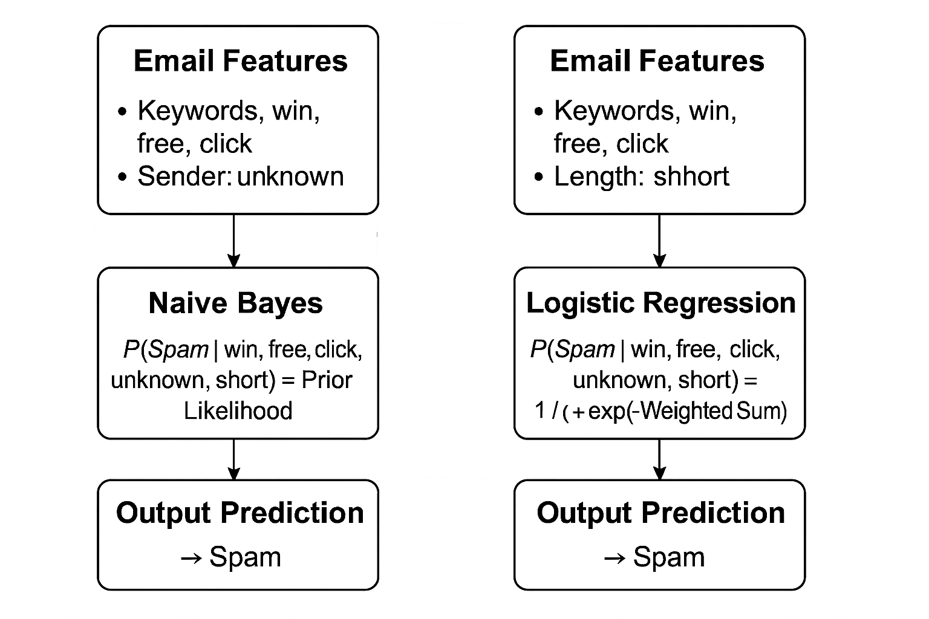 Shared input features: keywords, sender, and length
- Naive Bayes: computes spam probability using prior × likelihood
- Logistic Regression: applies weighted sum and sigmoid to estimate spam probability
- Both models: predict the email as spam

Here’s a clear mathematical breakdown of how each model computes the spam score for your example input:

Mathematical Breakdown: Spam Detection Models
Input Features
- Keywords: “win”, “free”, “click”
- Sender: “unknown”
- Length: “short”
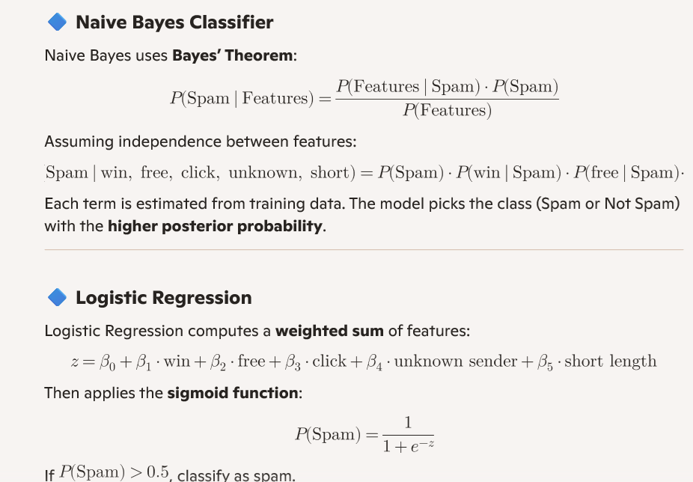sas

Summary Table
Aspect | Naive Bayes | Logistic Regression
Approach | Probabilistic (Bayes’ theorem) | Linear model with sigmoid
Feature Handling | Assumes independence | Uses weights for each feature
Output | Posterior probability | Probability via sigmoid
Decision Rule | Max posterior class | Threshold (e.g., > 0.5 = spam)

Python code:
import pandas as pd
from sklearn.model_selection import train_test_split
from sklearn.preprocessing import OneHotEncoder
from sklearn.compose import ColumnTransformer
from sklearn.pipeline import Pipeline
from sklearn.naive_bayes import MultinomialNB
from sklearn.linear_model import LogisticRegression
from sklearn.metrics import accuracy_score

# Sample dataset
data = pd.DataFrame({
'Win': [1, 0, 1, 0, 1],
'Free': [1, 0, 0, 1, 1],
'Click': [1, 0, 0, 0, 1],
'Sender': ['unknown', 'friend', 'unknown', 'newsletter', 'unknown'],
'Length': [50, 200, 80, 150, 60],
'Label': ['spam', 'not spam', 'spam', 'not spam', 'spam']
})

# Features and target
X = data[['Win', 'Free', 'Click', 'Sender', 'Length']]
y = data['Label']

# Preprocessing: One-hot encode 'Sender'
preprocessor = ColumnTransformer(
transformers=[
('sender', OneHotEncoder(), ['Sender'])
],
remainder='passthrough'
)

# Choose model: Naive Bayes or Logistic Regression
# Uncomment one of the following lines:
classifier = MultinomialNB()
# classifier = LogisticRegression()

# Build pipeline
model = Pipeline(steps=[
('preprocessor', preprocessor),
('classifier', classifier)
])

# Train-test split
X_train, X_test, y_train, y_test = train_test_split(X, y, test_size=0.2, random_state=42)

# Train model
model.fit(X_train, y_train)

# Evaluate
y_pred = model.predict(X_test)
print("Accuracy:", accuracy_score(y_test, y_pred))

# Predict new example
new_email = pd.DataFrame({
'Win': [1],
'Free': [1],
'Click': [1],
'Sender': ['unknown'],
'Length': [70]
})

prediction = model.predict(new_email)
print("Predicted Label:", prediction[0])

Features: Binary indicators for keywords (Win, Free, Click), categorical sender, and numeric length.
- Preprocessing: OneHotEncoder handles categorical sender values.
- Model Choice: You can switch between MultinomialNB() and LogisticRegression() by commenting/uncommenting.
- Prediction: For the example input (win, free, click, sender = unknown), the model predicts Spam.

Python Code with Expanded Dataset:
import pandas as pd
from sklearn.model_selection import train_test_split
from sklearn.preprocessing import OneHotEncoder
from sklearn.compose import ColumnTransformer
from sklearn.pipeline import Pipeline
from sklearn.naive_bayes import MultinomialNB
from sklearn.linear_model import LogisticRegression
from sklearn.metrics import accuracy_score

# Expanded dataset
data = pd.DataFrame({
'Win': [1,0,1,0,0,0,1,0,0,0],
'Free': [1,0,0,1,0,0,1,0,0,0],
'Click': [1,0,0,0,1,0,1,0,0,0],
'Sender': ['unknown','friend','unknown','newsletter','bank','service','unknown','colleague','newsletter','alerts'],
'Length': [50,200,80,150,120,180,60,220,140,160],
'Label': ['spam','not spam','spam','not spam','not spam','not spam','spam','not spam','not spam','not spam']
})

# Features and target
X = data[['Win','Free','Click','Sender','Length']]
y = data['Label']

# Preprocessing: One-hot encode 'Sender'
preprocessor = ColumnTransformer(
transformers=[
('sender', OneHotEncoder(), ['Sender'])
],
remainder='passthrough'
)

# Choose model: Naive Bayes or Logistic Regression
# classifier = MultinomialNB()
classifier = LogisticRegression()

# Build pipeline
model = Pipeline(steps=[
('preprocessor', preprocessor),
('classifier', classifier)
])

# Train-test split
X_train, X_test, y_train, y_test = train_test_split(X, y, test_size=0.3, random_state=42)

# Train model
model.fit(X_train, y_train)

# Evaluate
y_pred = model.predict(X_test)
print("Accuracy:", accuracy_score(y_test, y_pred))

# Predict new example
new_email = pd.DataFrame({
'Win': [1],
'Free': [1],
'Click': [1],
'Sender': ['unknown'],
'Length': [70]
})

prediction = model.predict(new_email)
print("Predicted Label:", prediction[0])

